
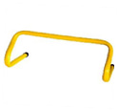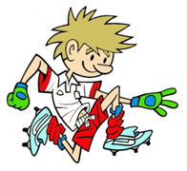
RULES – HOW TO PLAY

Set out 3 hurdles with 2 hoops and 3 bean bags in first hoop

Lift one bean bag for each run

Carry from red hoop over hurdles

Stop at line and try to throw into yellow hoop

One point for run

Bonus point for landing bean bag inside hoop

FOCUS
To develop the agility of children to hurdle jump and throw at a target

STATION 4: AGILITY
Activity: Bean Bag Transfer
HARDER
- Move through hurdles sideways
- Hop or jump over hurdles with both feet together
- Bring hurdles closer together or use taller hurdles

EASIER
- Slow movement down and emphasise one leg/arm at a time
- Use domes/hurdles to march over

COACHING POINTS

HEAD
- Head up and look ahead at all times

HANDS/ARMS
- Left arm/right leg vice versa
- Swing arms bend at elbows when running
- Use opposite arm to opposite leg when hurdling

LEGS
- Drive knees up and reach with toe while going over hurdles
- Snap leading leg down quickly after clearing hurdle
- Bring other knee over and around before landing
EQUIPMENT

- Small Hurdles

- Cones

- Hurdles

- Beanbags

- Hula hoops

Copyright Ulster Council GAA 2009

